**HBUD Installation and Use Guide**

Version 04v00

August 2011

**Oregon Department of Transportation**

# Table of Contents

Table of Contents 2

Introduction 3

Installing HBUD 3

Un-Installing HBUD 5

Generate HBUD EXTRACT Data 6

Downloading the HBUD Data Extract 7

# Introduction

As part of the TRANSINFO implementation project, ODOT has asked Exor to provide a data extract from the TransInfo system to be supplied to the HBUD system. HBUD is used by the maintenance group to plan and monitor budgets. This file must be compiled from data in TransInfo including asset records, their location on the network, and the associated ‘activities’. It must then be extracted and made available to ODOT to load into HBUD.

# Installing HBUD

Extract the HBUD software to the EXOR BASE

e.g. C:\exor4101\ (or the equivalent on your schema)

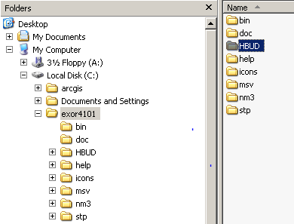

Open a command window and change directory to the C:\<EXOR BASE>\HBUD\install folder

Connect to SQLPLUS as the HIGHWAYS owner.

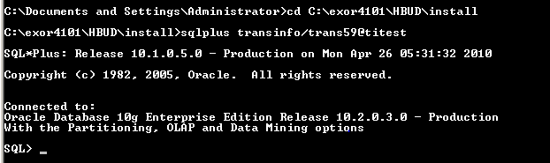

Run the following command:

@hbud_inst.sql

Enter value for exor base e.g. C:\exor\

Type Y to continue.

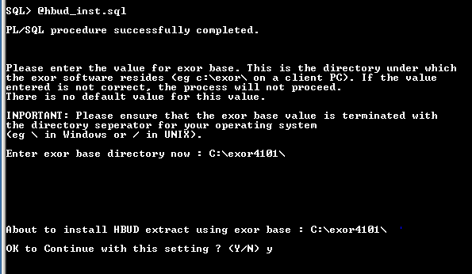

Check the log files that have been generated in C:\<EXOR_BASE>\HBUD\install for errors.

hbud_install_1_<date and time>.LOG

NOTE : **Warning: Package created with compilation errors.** This message can be ignored.

hbud_install_2_<date and time>.LOG

Navigate to C:\EXOR_BASE\bin and open the exor_version.txt file.

Add HBUD=4.0.0.0 to the bottom of the file.

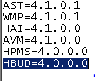

Installation is now complete.

# Un-Installing HBUD

Un-installation of the HBUD Software installation is done via the same Oracle SQL interface. If the software files have not been extracted, extract to a known location i.e. c:\exor\. Un-installation of the software is detailed in the following steps:

1. Login to the Oracle SQL interface using the Highways Owner schema. The System Administrator will have the correct username and password for this task.
2. Run the un-install script:
   1. Start c:\<path to install folder\Version_3.0\admin\sql\hbud_uninstall.sql
   2. An uninstall log will be created in the event of any errors during un-installation.
3. The uninstall script will remove all procedures, metadata and database objects installed during the initial installation of the software.

# Generate HBUD EXTRACT Data

From the launch pad navigate to HBUD>Regenerate HBUD Data.

Double click on Regenerate HBUD Data, this will start the process or regenerating the HBUD data extract.

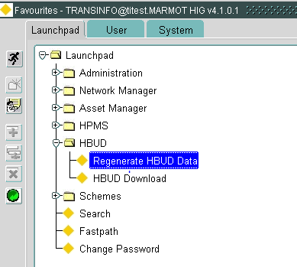

Once the process is complete the message” HBUD Generation Complete” will be displayed as shown below.

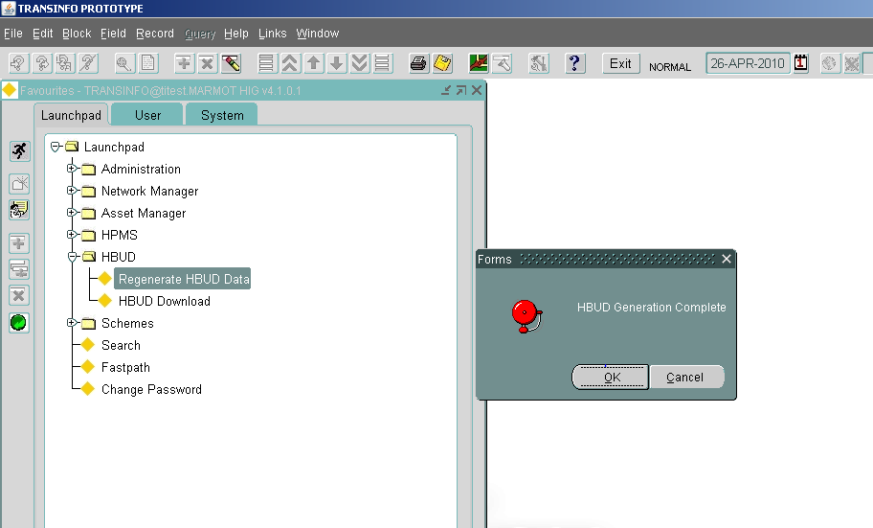

# Downloading the HBUD Data Extract

From the launch pad navigate to HBUD>HBUD Download.

Double click on HBUD Download.

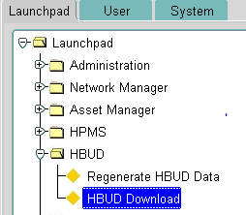

The following web page will load:-

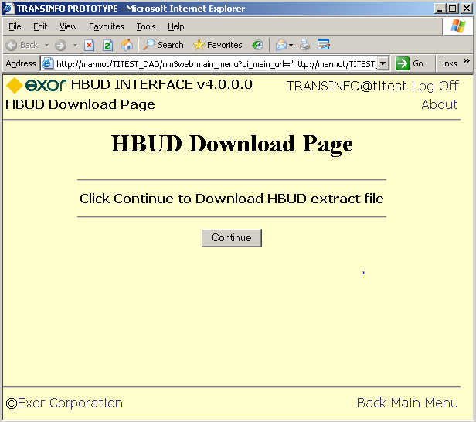

Click the continue button.

The file will be generated and the following page will be displayed.

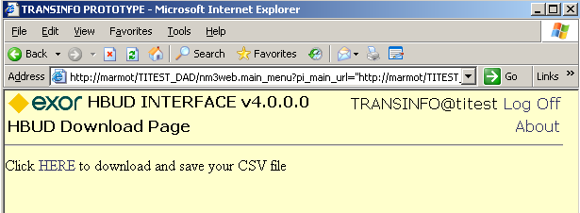

Click HERE, will present the user a file download dialog box:-

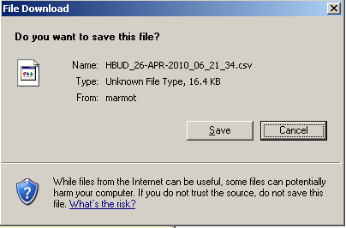

Hit the save button.

Choose a location on the user’s local machine to save the file too.

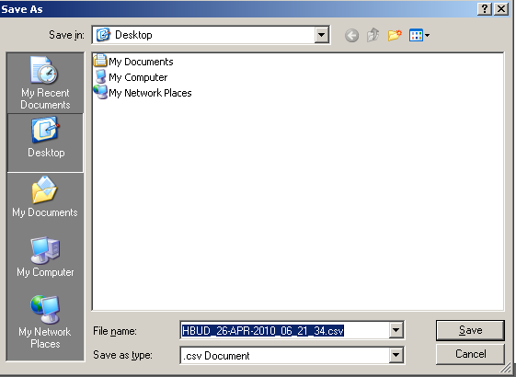

Process complete.